**CSI3660 Lab 1 – Google Cloud**

For this lab we are going to work with Google Cloud to setup a micro-instance of a virtual machine. This will supplement the eventual virtual machine you will receive from Oakland.

As this is your first lab with me, and I’m not physically there to walk you through this, please **read this manual carefully and follow along.** There will be homework questions seeded throughout this document asking you to take a screenshot here or there, report information, etc., and you won’t be able to go back to it without starting over.

To nip the question in the bud, yes, you must provide an answer to all questions. If you missed a step, then that is on you to fix. Again, **read carefully**.

You can create as many VMs as you want, but keep in mind that your account will be charged for each moment a VM is online. **Note that you should never put your personal credit card information into the site. This is 100% free for you.**

The reason we’re using a micro-instance is that it is free to your account, as long as you don’t send/receive too much data. More info here on that: <http://cloud.google.com/free>.

**Account Setup**

You should have received an email forwarded from myself containing information for signing up for Google Cloud. Your Oakland email is required for the first form, as that will send you the coupon.

The second email you get will be a coupon code to redeem. Click the link to redeem and then read the following **very carefully**.

YOU MUST HAVE A **PERSONAL GMAIL ACCOUNT**. IF YOU USE YOUR SCHOOL EMAIL FROM HERE ON OUT THIS WILL NOT ONLY NOT WORK, BUT YOU WILL **NOT** BE ABLE TO FINISH THE LAB.

When you go to sign up for coupons, make sure the icon for your **personal** Gmail account is active. It is in the top right corner. This is mine. Note it is my personal email icon, it is not my Oakland profile image:



Easiest way to make sure is to click the profile icon and check that your oakland.edu account is not active. Your Oakland email should either be signed out or grayed out.

Click the link in your email to sign up for the free Google Cloud credits, making sure to copy the unique code.

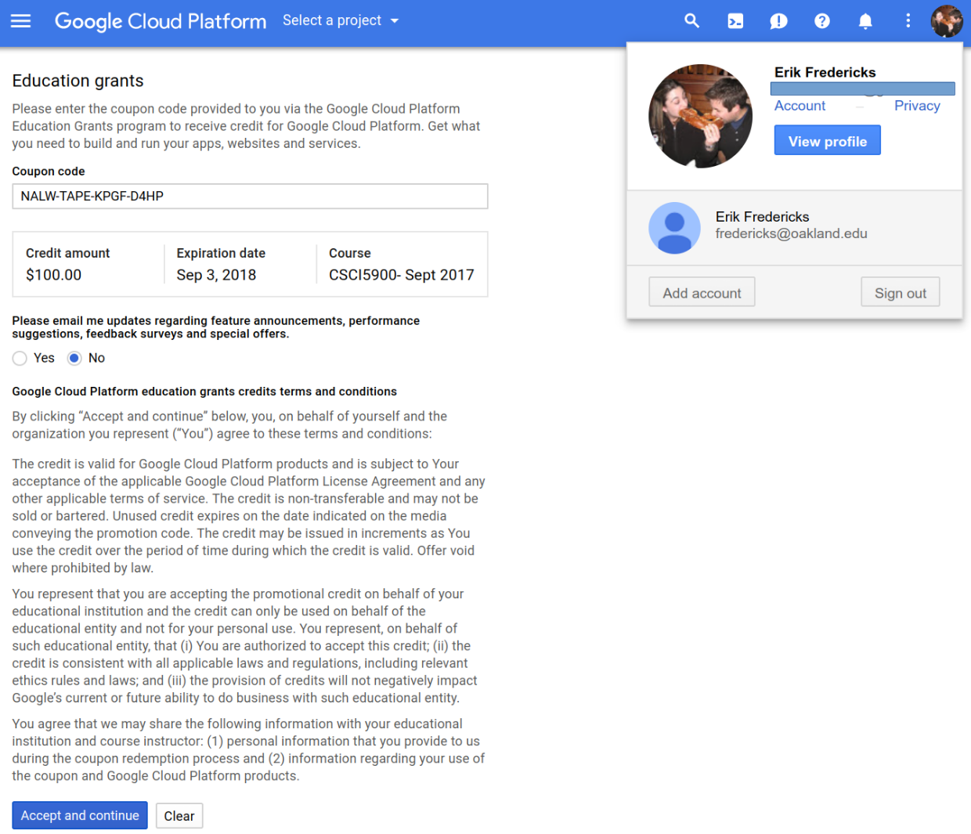

Note that my personal Gmail account (email redacted) is active. Also, the code above will not work for you, as I have redeemed it for teaching purposes. You should have a **$50** credit in your account. If you run out of money, I can request more for you, however that will require turnaround time for Google to approve it.

Ok, now you should have a billing account. You can access this at <http://cloud.google.com> now whenever you want. Google Cloud itself is really outside the scope of this lab, however I’d recommend reading up on its capabilities (hint: there are a *lot* of cool things you can do with it).

You should be dumped to a screen that looks like this:

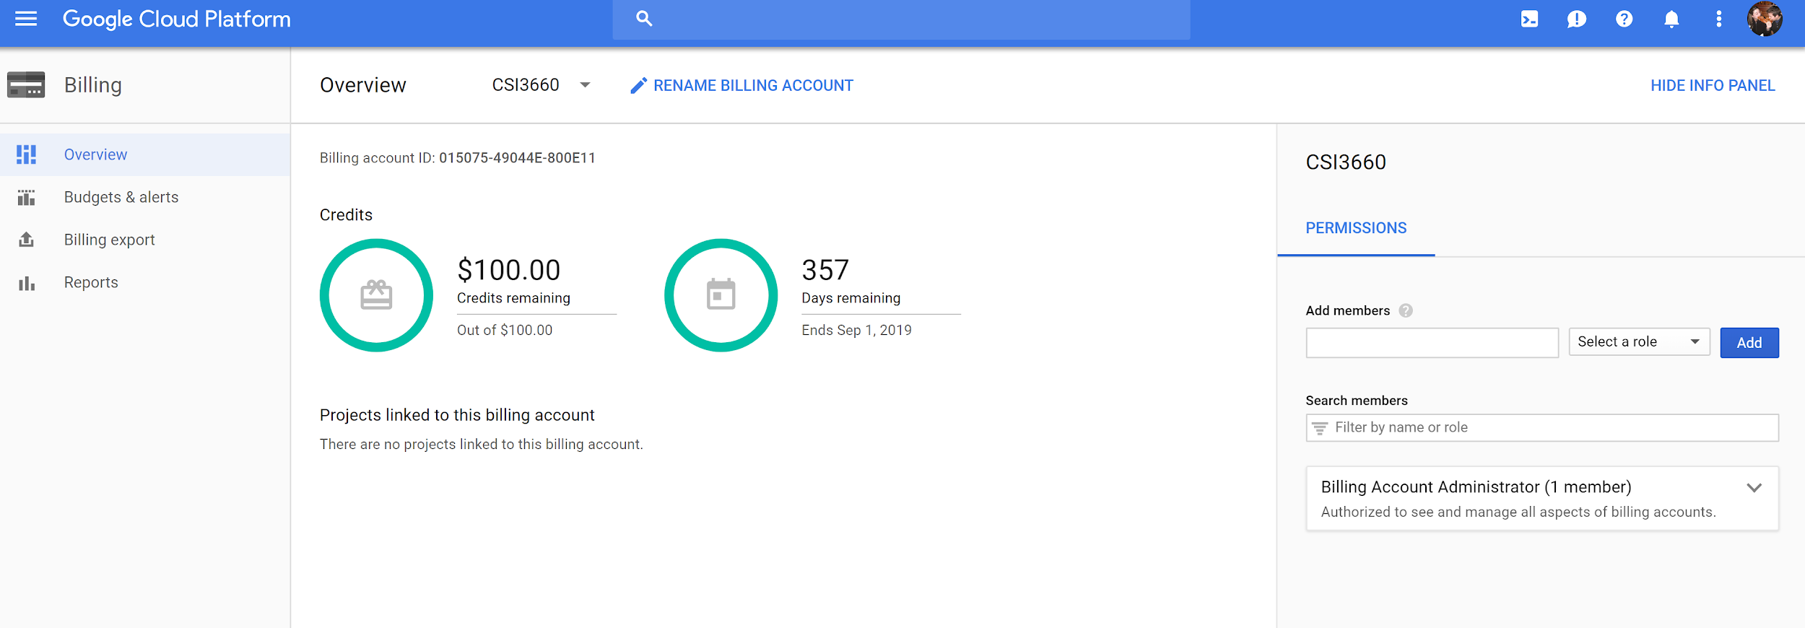

This is the Billing page. It tells you how much money you have in your account. All of your Projects will be linked to this billing account. This is how cloud computing works.

We now need to create a project for the class. The project will contain all VMs related to the class. Click the Google Cloud Platform logo on the top left to bring you to the home page (also accessible via <https://console.cloud.google.com>).

You should see a card titled **Project info**. Click **Go to project settings** and you should see a similar window to this:

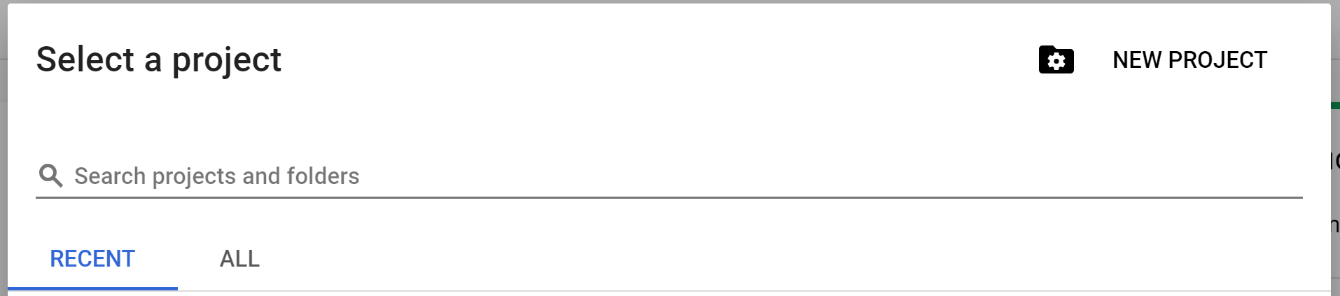

Click New Project and name it **CSI3660-F2018**. If it complains that it is not unique, add your last name to the project name. Select your newly created billing account and leave the organization alone. It should look like this:

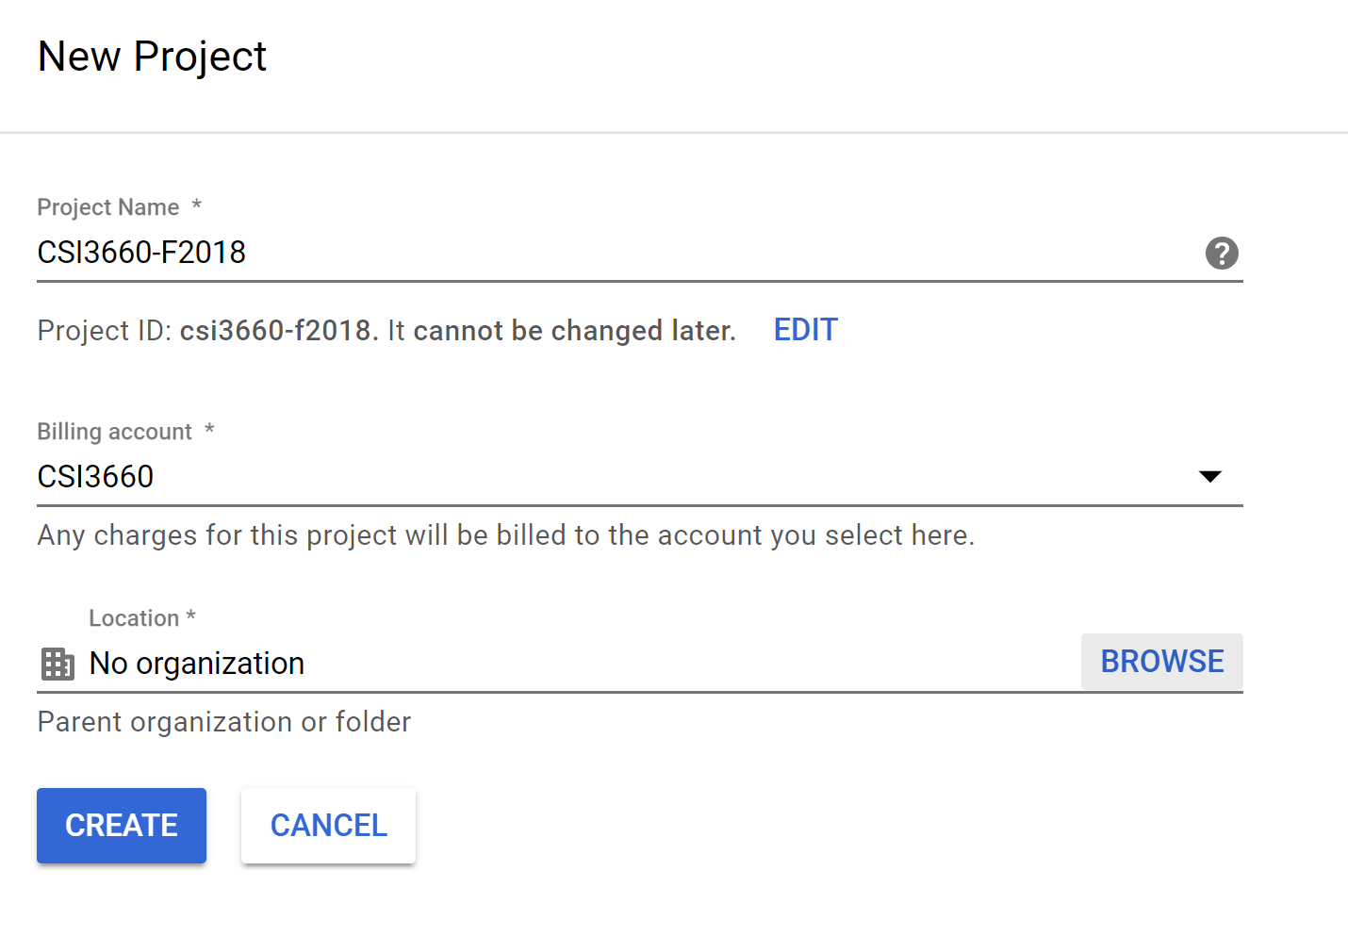

This may take a little while, depending on the speed of Google. At the top right you’ll see an icon like this:



If it is spinning, then Google is working in the background. You can click it for more information.

Once it’s done, select your newly-created project from the drop down at the top of your cloud console.

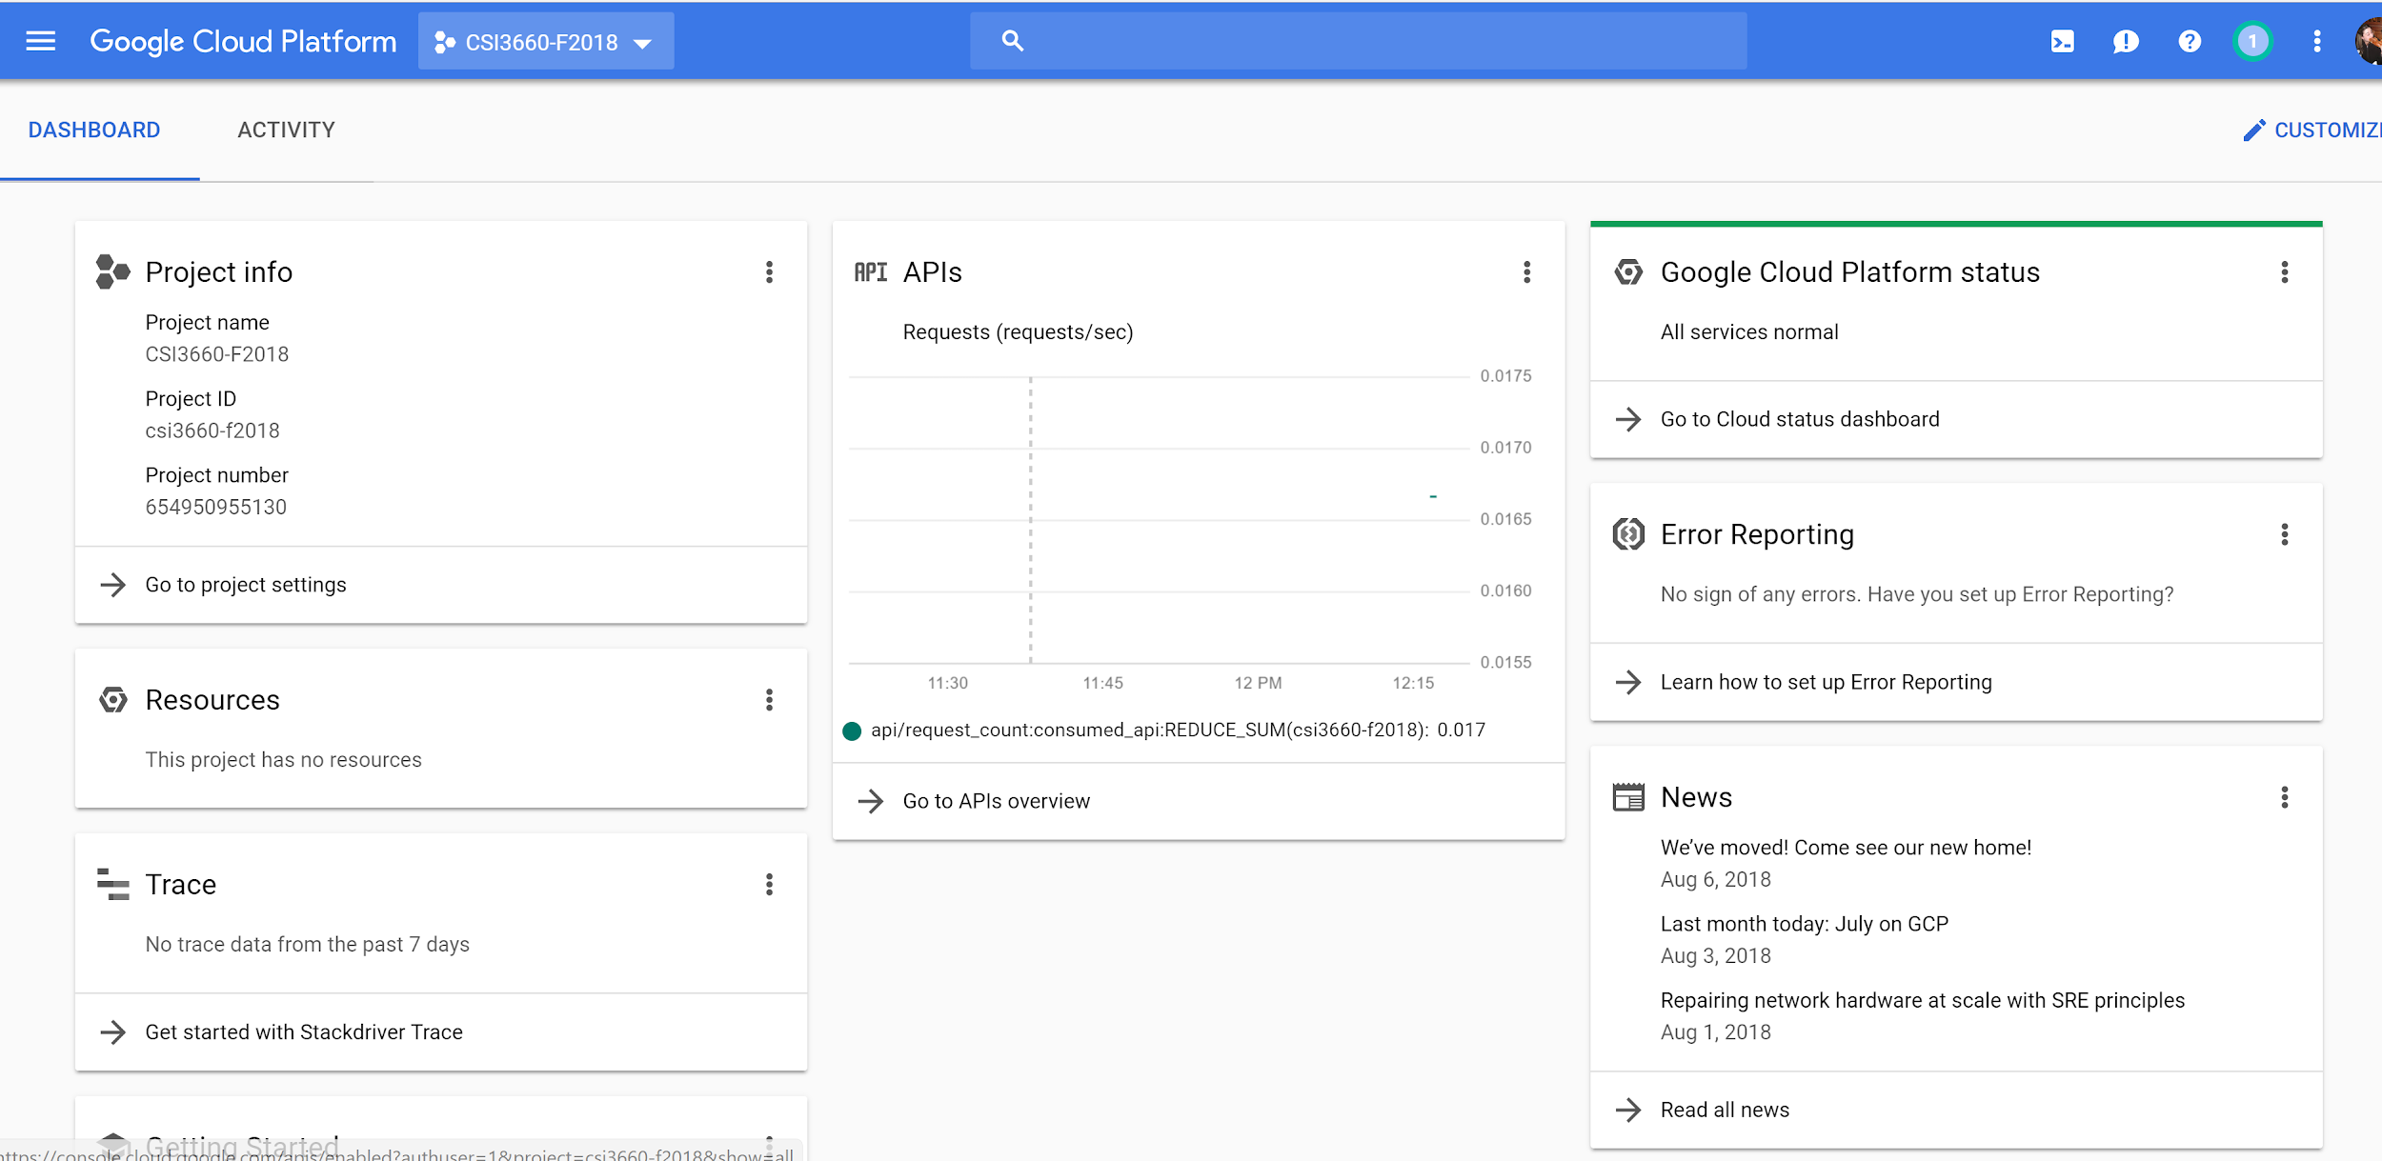

**VM Creation**

First, click the options menu (3 horizontal lines) on the top left and then click Compute Engine.

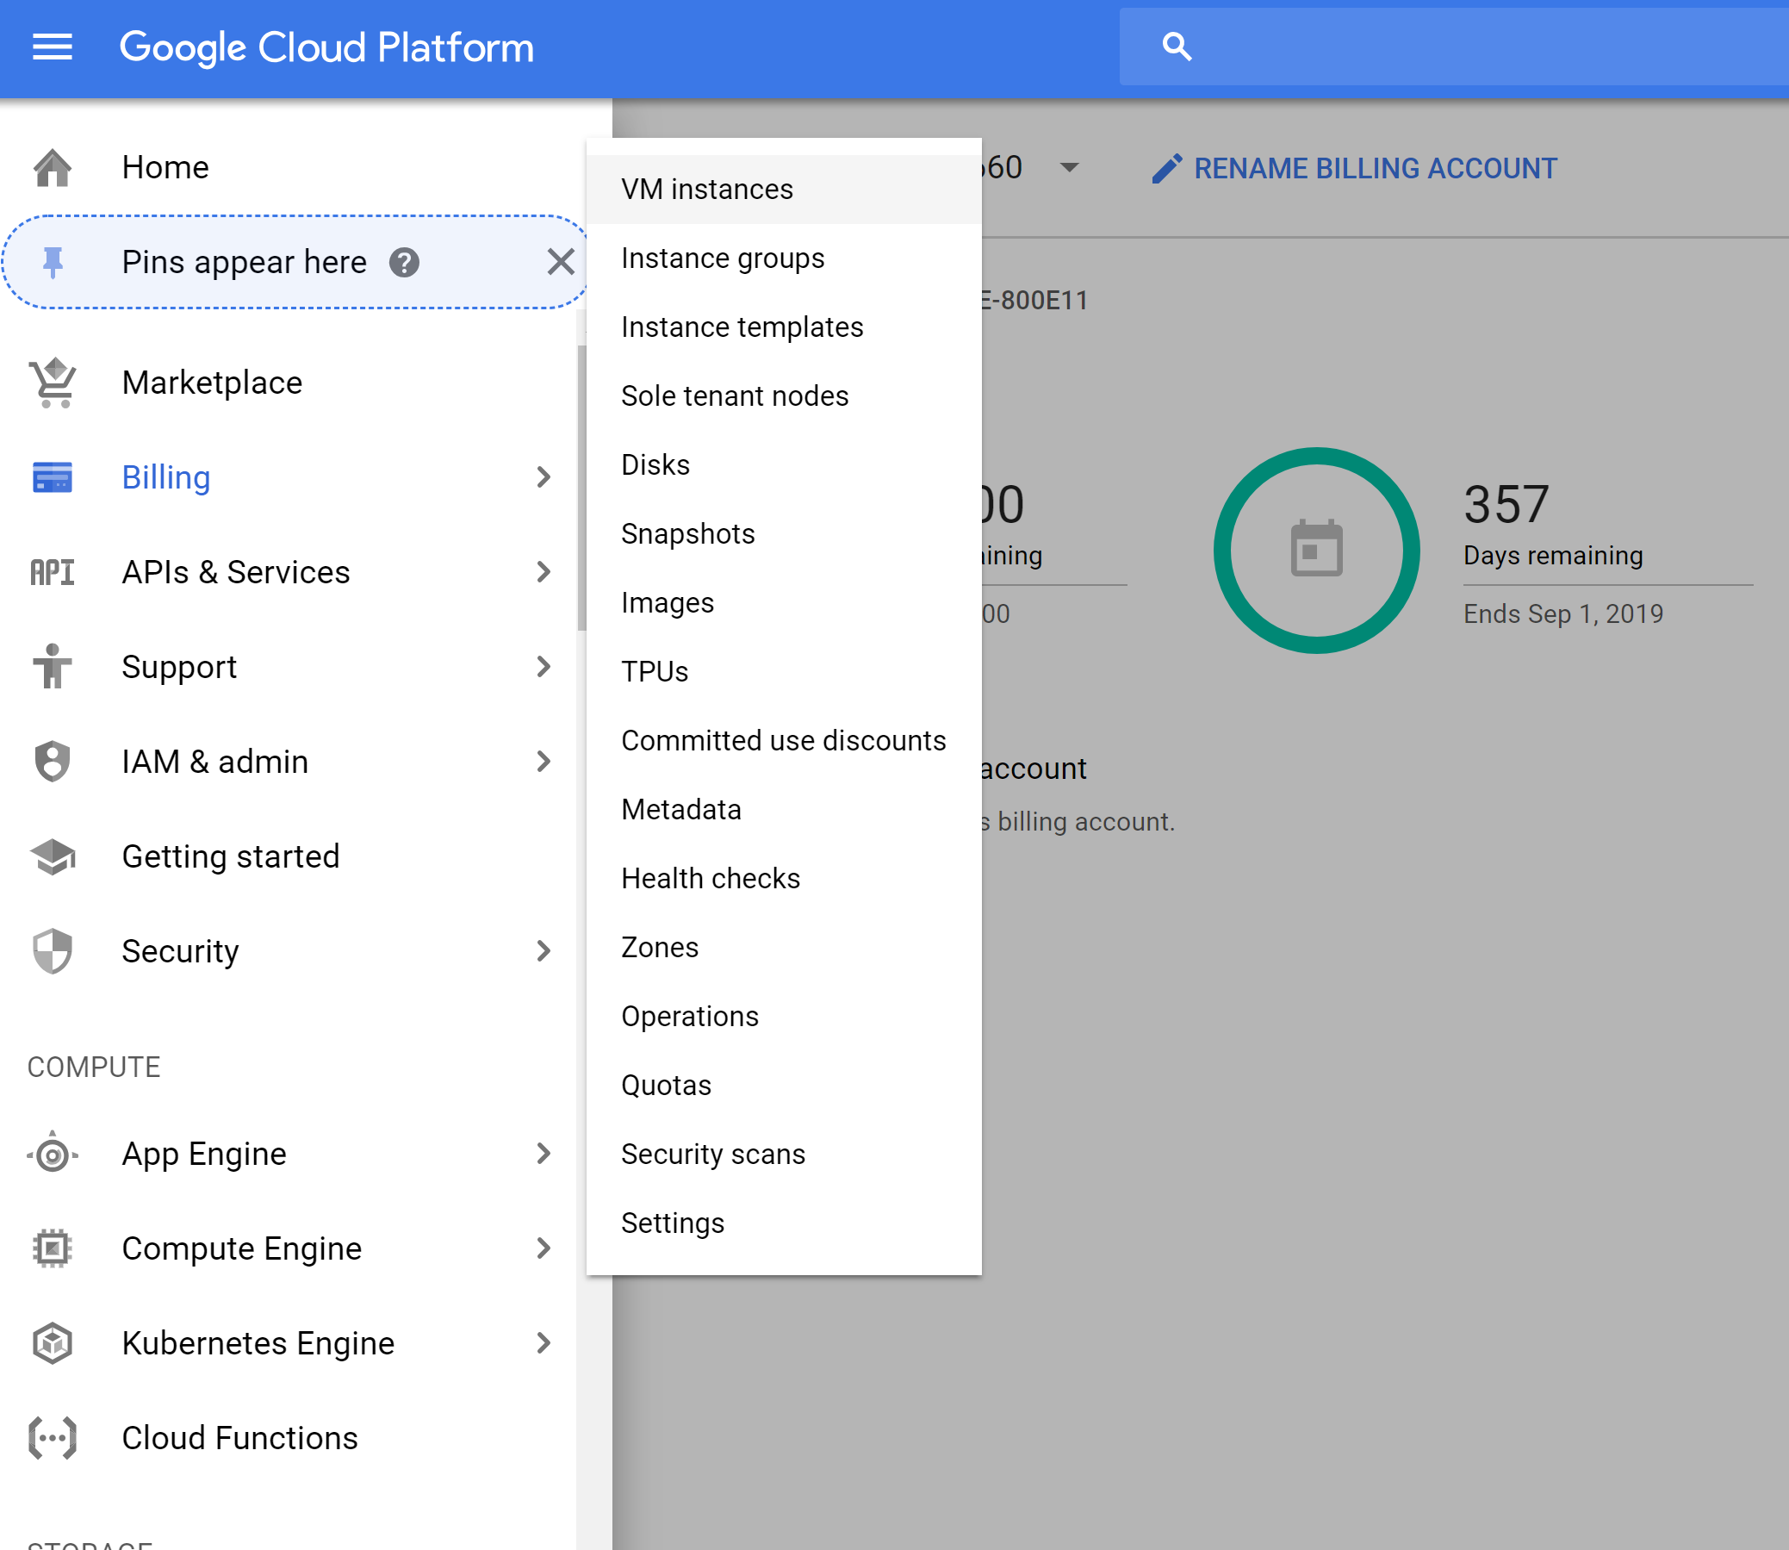

It may take a few moments for Compute Engine to initialize. Once it is done, click the **Create** button. You’ll be taken to the VM creation page. Name it **csi3660-microinstance-1** (this name can be up to you, but it is helpful to name it as related to its task -- if you get a non-unique name error than add on your last name to it). The region and zone should be us-east as that is closest to you, but note all the different regions you can create a VM on.

Now, play with machine type a bit, noting the changes in cost on the right. If you want a beefy machine, then you’re going to pay a lot for it. We’re going to go for the smaller model, because again, it is free.

We’re also going to use CentOS7 as Scientific is not an option on here. Don’t worry, CentOS and Scientific are quite similar.

Your screen should look like this:

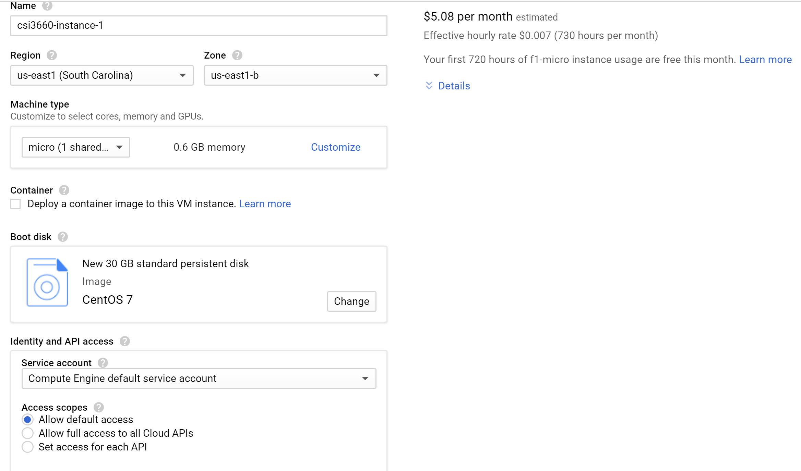

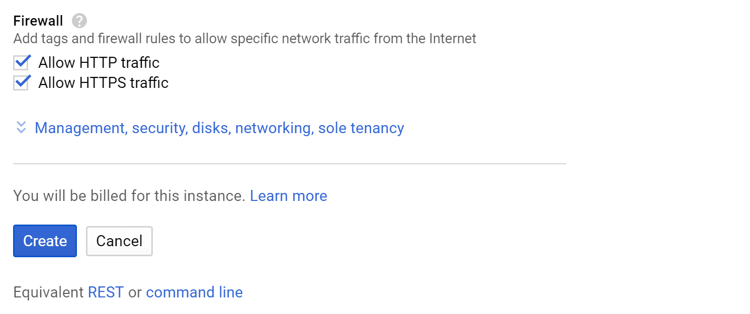

The VM instance creation will take a few minutes.

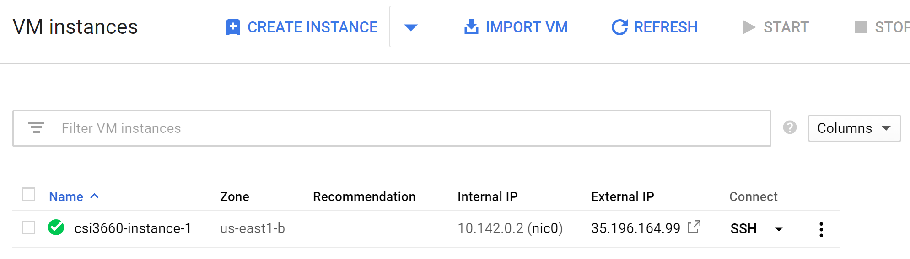

So now that's the instance is running (green check), open the instance by clicking its name and looking at the details and monitoring tabs. You should see information related to performance that look like graphs. **Take a screenshot of the CPU and Network graphs and paste it in Q1.**

---

**Remote Access**

It is now time to SSH into your server. Google Cloud makes this ridiculously easy to do in the browser (we will talk about SSH keys later). Go back to the VM instances page and click the SSH button:

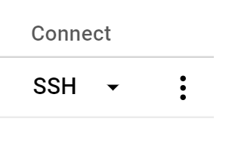

This will pop open an SSH window, similar to this:

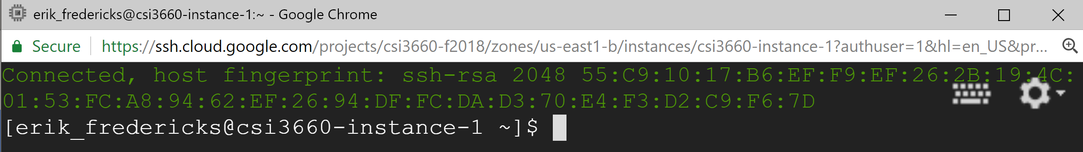

**Take a screenshot of yours and paste it into Q1**.

Yay! You are now in your Linux virtual machine. Now we should make sure our machine is up to date. This is something that should be done fairly regularly to make sure things like security updates are applied to your software.

In the terminal, run (without the dollar sign, that is an indicator that you should type a command into the shell):

$ sudo yum update

You’ll probably see something like this:

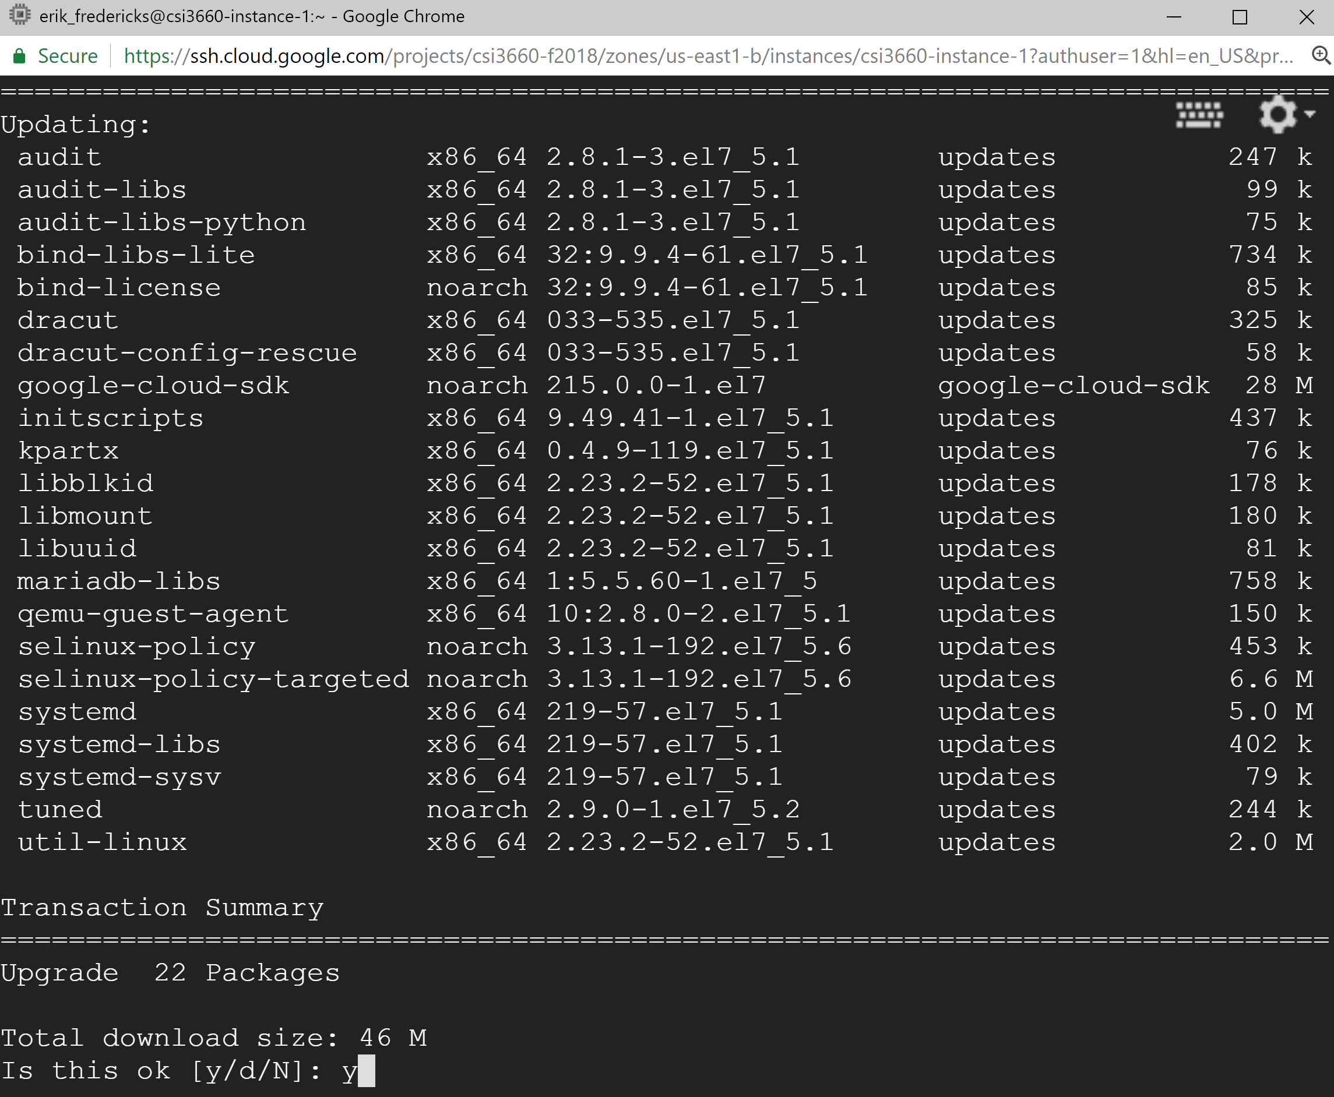

Type **y** and hit enter to accept.

(If you are a Debian/Ubuntu person, this will be different than what you normally do. In RHEL-based operating systems, yum update takes care of the update && upgrade strategy)

**Command Line**

Lets see how much storage that we have on our VM, please enter:

$ df -h

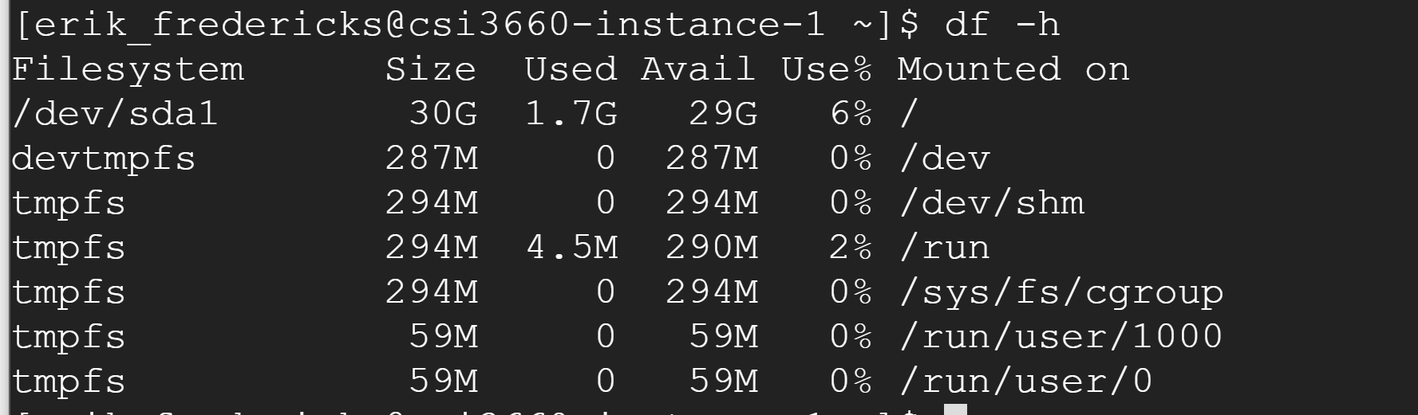

(This is mine, yours may look different)

**In Q2, describe how much free space and total space is available on your virtual machine’s hard drive. Also, what is your hard drive called?**

We will come back to this VM in another lab as it is going to be your web server. The reason we made it micro was for you to be able to leave it on all the time. However, since we’re not setting up a web server in this lab you can just stop it for now.

In the VM instances page, click the 3 dots next to your instance and Stop.

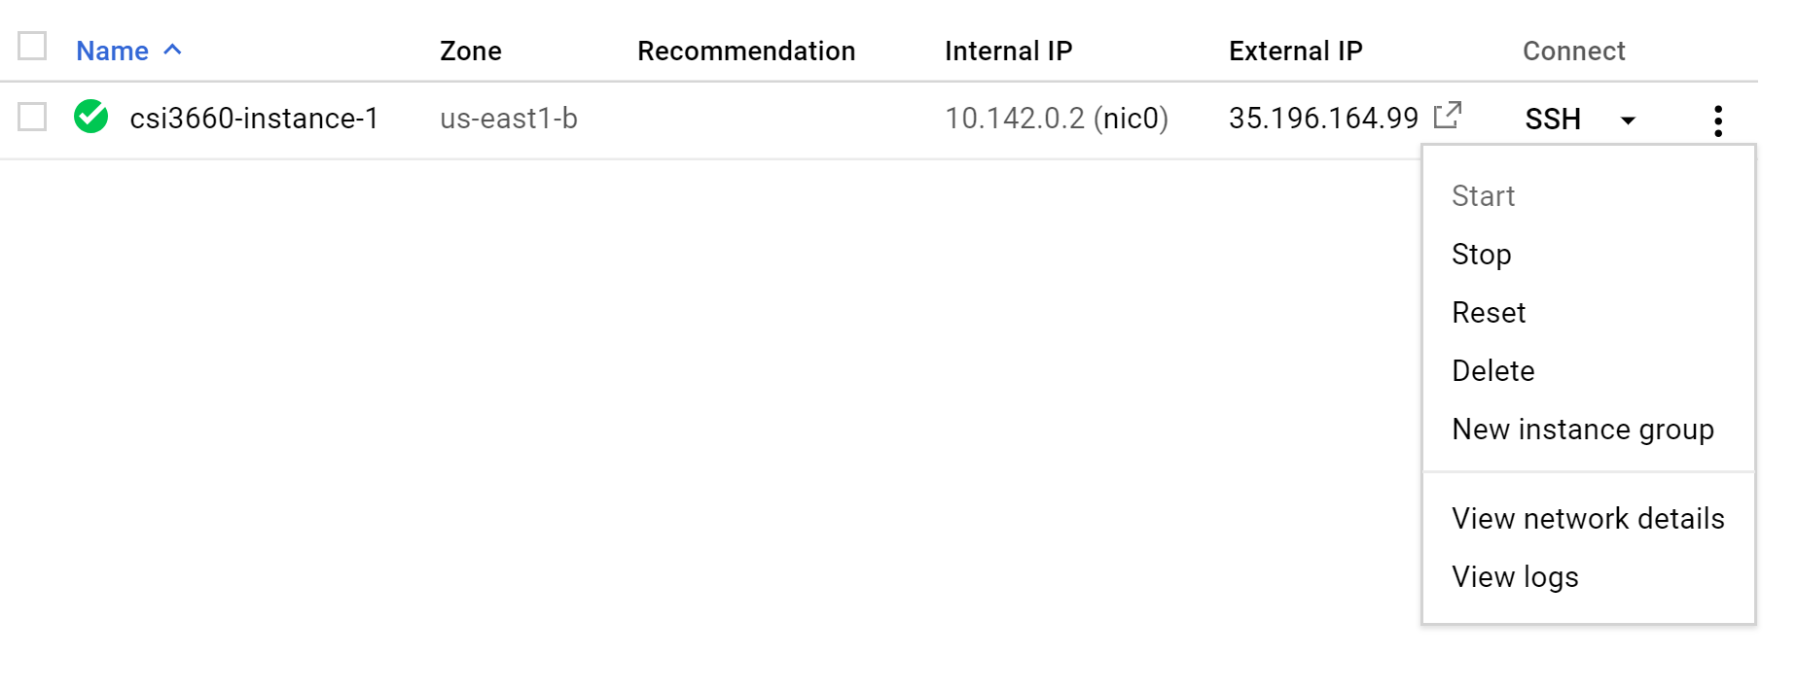

Again, this is a cloud computing thing! Each second your instance is running, you are being charged (except for the micro instance, which Google provides for free -- note that other providers have different cost strategies).

Now, create another VM instance. This will be a workhorse for us. Name it Pick **CentOS 7** again, but give it a **50GB** hard drive with **1 vCPU** and **3.75GB** of memory. Allow HTTP/HTTPS traffic. Run yum update to update its packages.

**Admin Access**

You now need to grant me Owner access on your Project so that I can also manage your VM (to check homework, etc.). Open up the IAM page (go to the Search bar at the top and type IAM). Click IAM & Admin. On your project for CSI3660, add me as an owner.

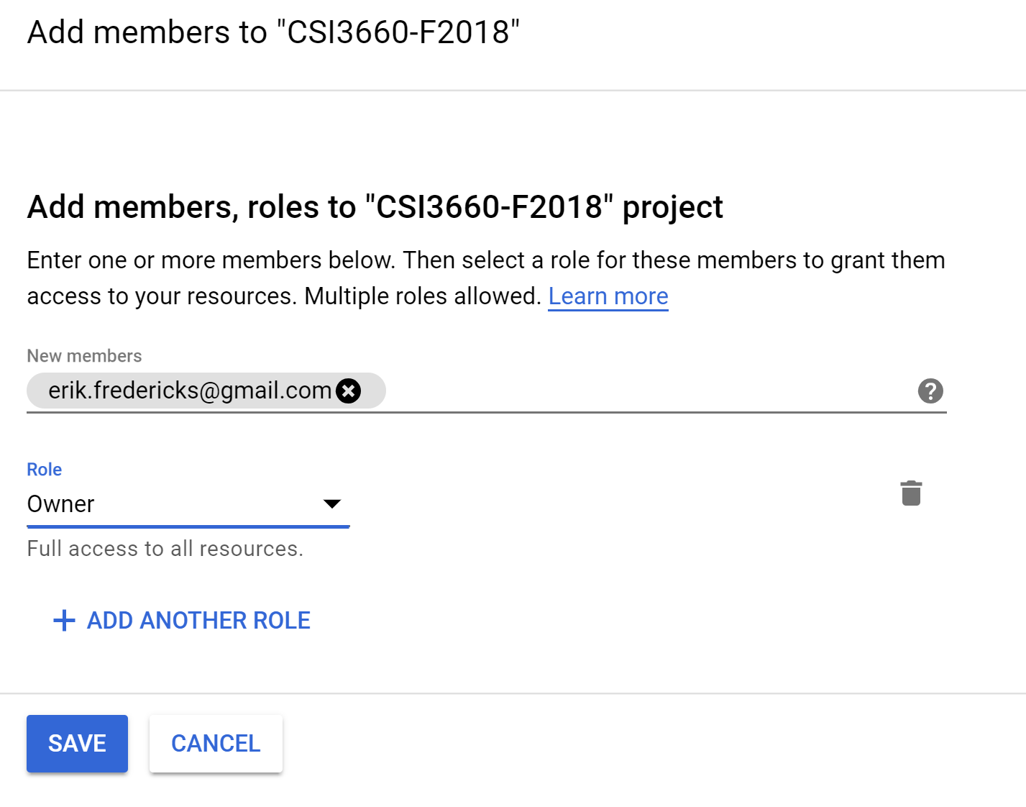

Make sure that you stop your instance after you’re done to preserve your credits! **Take a screenshot of your two instances stopped and paste it into Q1.**

**Submit the last page of this report to Moodle only. Save it as <your last name>_Lab1 and also make sure your name is inside of the report as well.**

**Name:**

**Date:**

**Homework 1:**

1. Please add the **three screenshots** from the lab section and insert them below.
2. Describe how much free space and total space is available on your virtual machine’s hard drive (the micro-instance). Also, what is the name of your hard drive on the system (it can be found in that command you ran)?
3. What protocol are you using to connect to your remote Google Cloud server? Why is this better than a protocol like telnet? (You may need to look up telnet).
4. What are **two** benefits of using Google Cloud over, say, our local VM server with CTO?
5. Why do you need to stop your VM instance when you are done?
6. If you wanted to connect to your Google Cloud VM, what is the single IP address for each that you would connect to if you are **outside** of the Google Cloud infrastructure (e.g., you are trying to visit a website you setup on the VM)? For this, take a long hard look at the VM instance details...